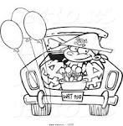
Live Oak Elementary School’s First Ever
Trunk-or-Treat

Halloween is here…come celebrate it with your
Live Oak community!

Friday, October 31st from 6:30 – 7:30 p.m.
In the Deer Park Middle School parking lot

Bring your entire family and a trunk full of store bought treats!
While parents get ready for Trunk-or-Treaters’, children can dance to Halloween music and parade their costumes around the parking lot.

Come park your car between 6:00 p.m. – 6:30 p.m. in the Deer Park Middle School parking lot (adjacent from Live Oak Elementary). The entrances will be closed to all traffic starting at 6:30 p.m. until 7:30 p.m. Cars that park in the school parking lot will not be permitted to leave early; this makes it safe for all who come to walk freely around the parking lot.

Attractions
Glow Necklaces for $1 in multiple colors
Glow bracelets for 50₵ multiple colors
Austin Fire Department fire truck FREE

Please remember our main goal is to have fun and keep children safe… families parking their cars are required to stay for the entire event.

Questions? Call David Chaney at (512) 428 - 3879

Trunk-or-Treat Donations
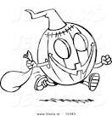
If you would like to donate candy to our Trunk-or-Treat event please send in candy donations before Friday, October 31st. The candy will be used to replenish trunks that run out of treats on the night of the event.
ALL donations will are greatly appreciated!!!!

Donations can be dropped off in the front office.

